**Prepared by: Fook Yen Edwin Chan**

**Topic –** CSS

**Topics Needed –** background-color/ font-size/font-family/color/text-align/border-radius/margin-left/box-shadow/margin-right/margin-top/margin-bottom/-webkit-transform(scaleX)/transform/letter-spacing/word-spacing/outline-width/display/margin/class declarations + CSS based on class.

**Title –** Food Around the World!

**Description –** This program will give you an opportunity to use many of the basic CSS tags that are used in nearly every web page. The basic webpage, Food.html is provided for you. Try to create CSS file and name it **food.css**. Try to make the page look as similar as possible to the provided screenshot. Feel free to try out different CSS tags and experiment with different attributes from different tags!

**Step-by-Step Instructions**

1. Open the html file **Food.html** in the same directory as all of the images.
2. Add the following line to right below the Title tag:

*<link rel = "stylesheet" type = "text/css" href = "food.css"/>*

1. Create a css file food.css in the same directory.
2. Now, lets try to make the background of the page blue! In the food.css, create a css schematic for body, like as following:

body {

}

1. Inside the curly braces, set the attribute **background-color** as **lightblue.**
2. Now, let’s try to adjust the font and position of all contents within h1 tags in the html! To do that , create a h1 CSS scheme, and set **font-size** as **30px, text-align** as **center.**
3. To make it less dull, let’s change the color of the heading! In the h1 CSS scheme, set **color** as **red**.
4. Now, the words in the paragraph looks too small. Try to make it larger by creating a CSS scheme for p tag and set **font-size** to **15px.**
5. Now let’s try to change the font of the paragraph. In order to do it, in the CSS scheme for p tag, set **font-family** to **Verdana.**
6. Now, let’s render with the images! In order to do so, create a CSS schematic for img tag, and set **border-radius** attribute to **10%.** See what happens!
7. Now, it seems like the food pictures are too close to the left boundary. Try to make it to space out a little from the left border. In order to do so, create a schematic for ul and set **margin-left** attribute to **30px.**
8. Now let’s try to make the images look 3D! In order to do that, set **box-shadow** to the following value:

**0 3px 8px 0 rgba(0, 0, 0, 0.2), 0 5px 20px 0 rgba(0, 0, 0, 0.19)**

1. Let’s try to add filter to images! In order to do so, set **filter** attributeto

**drop-shadow(2px 3px 5px black)**

1. It seems like there should be more room between pictures and words. In order to do so, in img scheme, set **margin-left, margin-right, margin-top, margin-bottom** to **20px.**
2. Let’s add a frame/outline to the webpage! In order to do so, in body scheme, set **outline-style** as **solid** and **outline-color** to **red.** If you want to set the outline-width, you can set **outline-width** element to **a certain px, say 5px.**
3. Now let’s get to some more advanced CSS with img tag! In order to make the image responsive, lets use webkit and use pseudo-classes to make the images reactive! Declare a pseudo-class of img as the following: img:hover {} and inside the scheme do the following:

**-webkit-transform: scaleX(-1);**

**transform: scaleX(-1);**

1. Now try to hover your mouse over the image to see the magic!
2. Now try to render with the title! In h1 CSS schematic, set **letter-spacing** as **2px**  and **word-spacing** as **5px.**
3. Do you know that you can also set attributes according to a html tag’s class? In order to do so, declare a class for the tag. An example has been done for you by setting all the countries with **class=”countries”**. Declare a schematic for such a class by the following:

**.countries{**

**}**

and make the **text**  **blue** and **align-center.**

1. Now try to declare classes for all the images of the food and **center these pictures ( hint : try to set display and margin attributes.** )

This is the end of the assignment

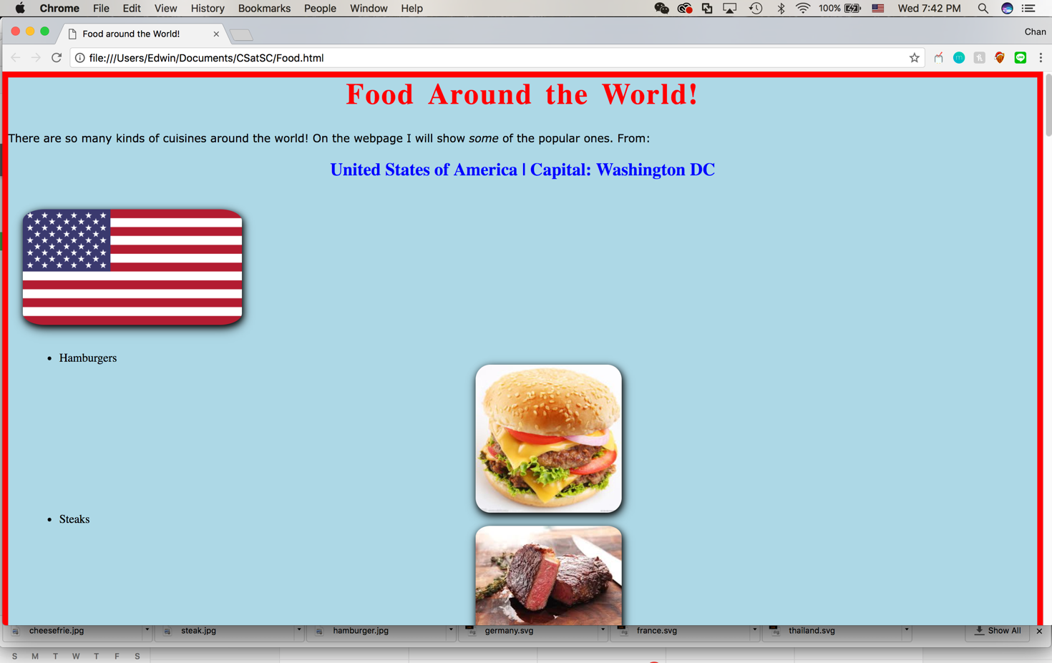**Screenshot**

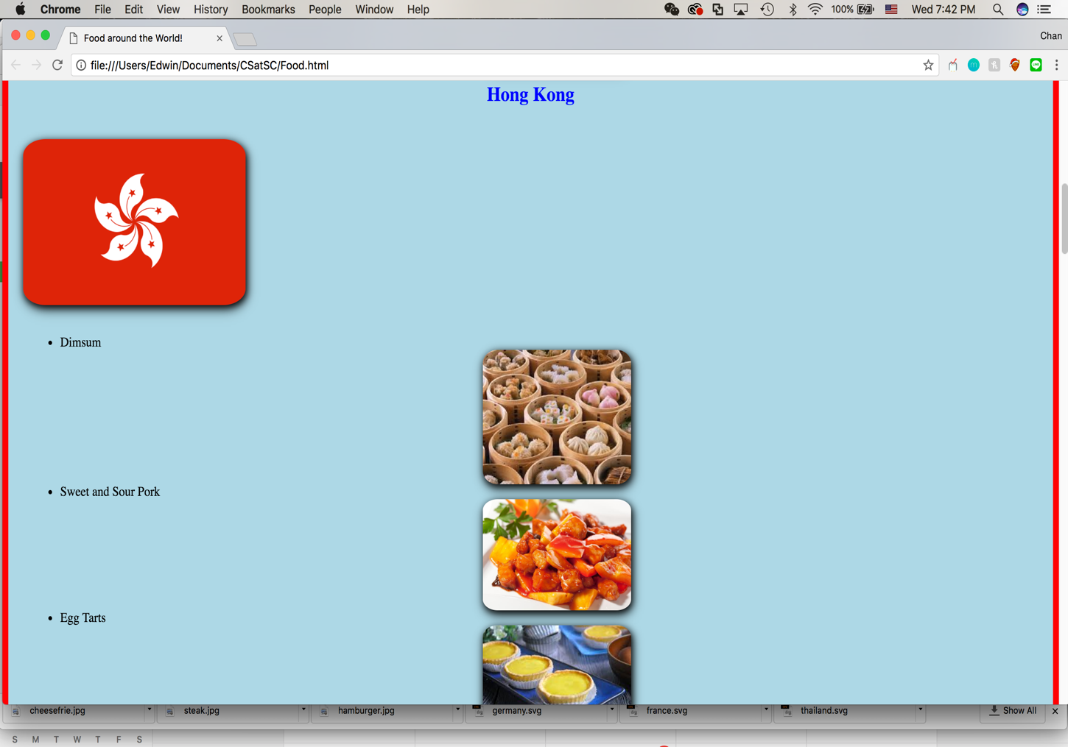

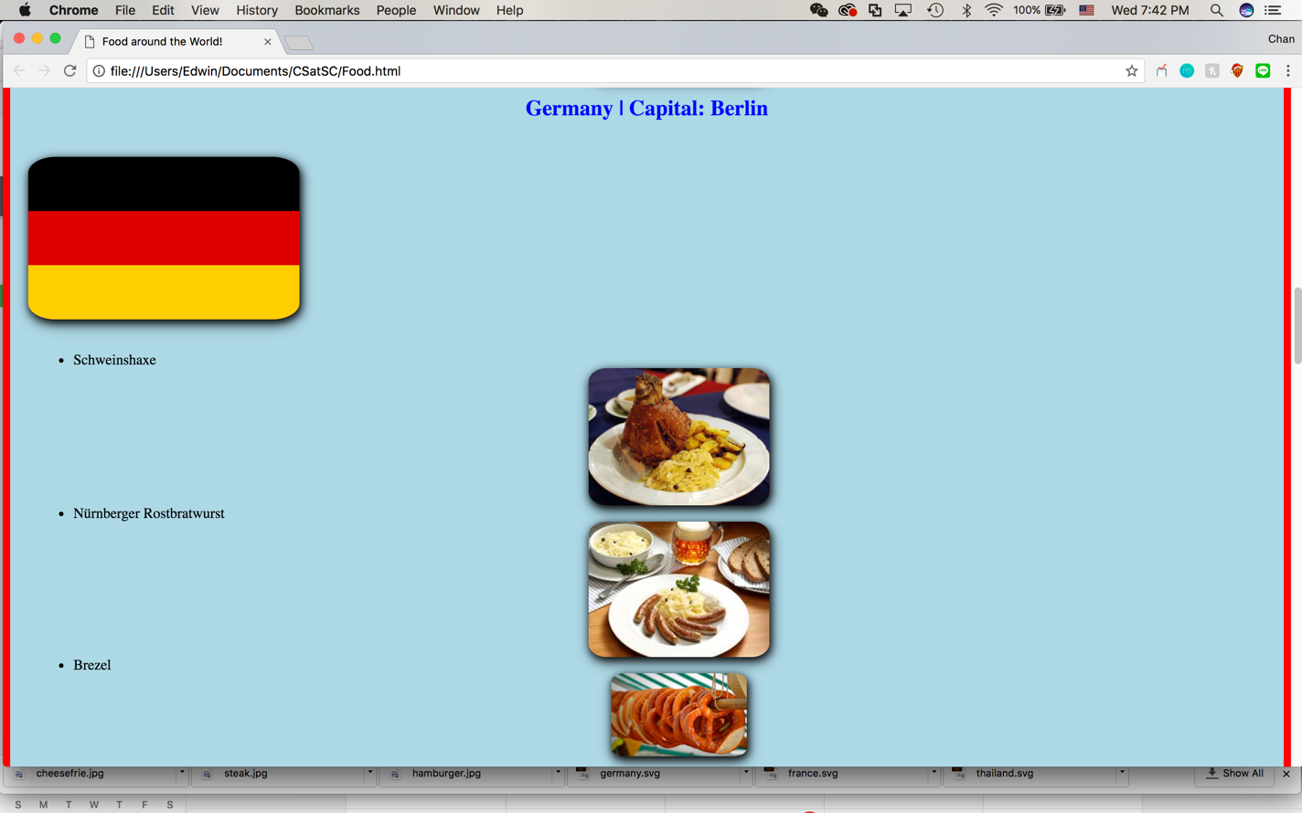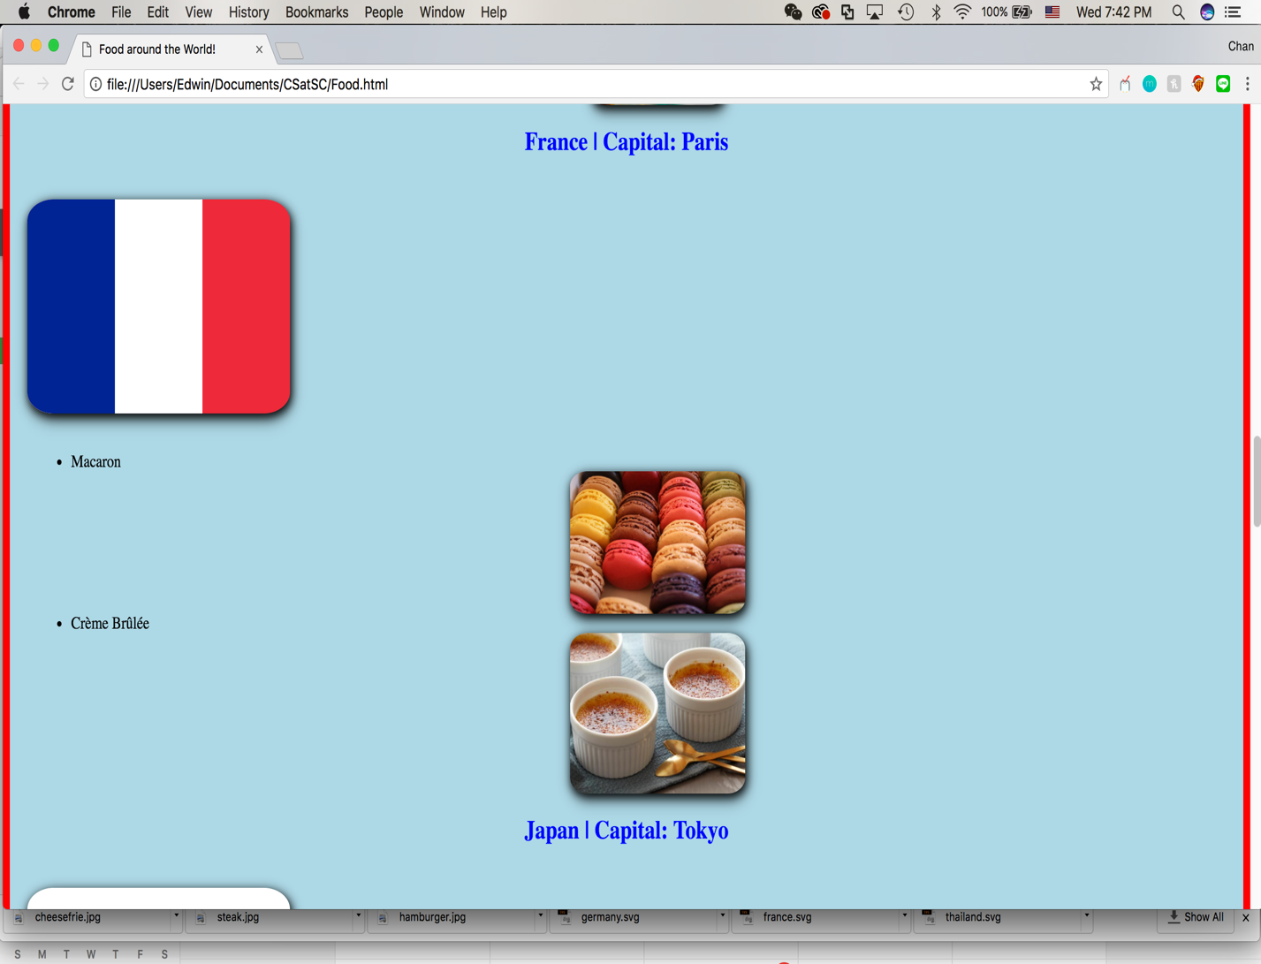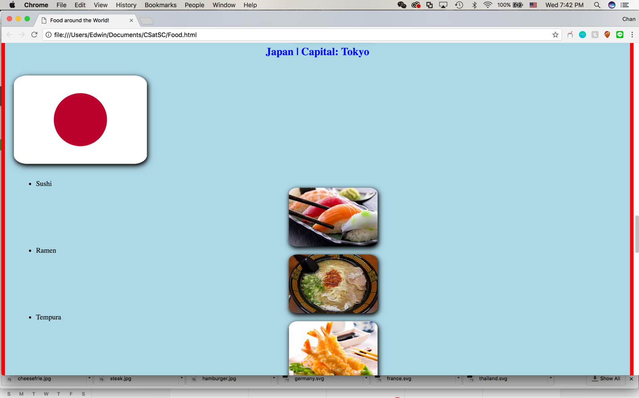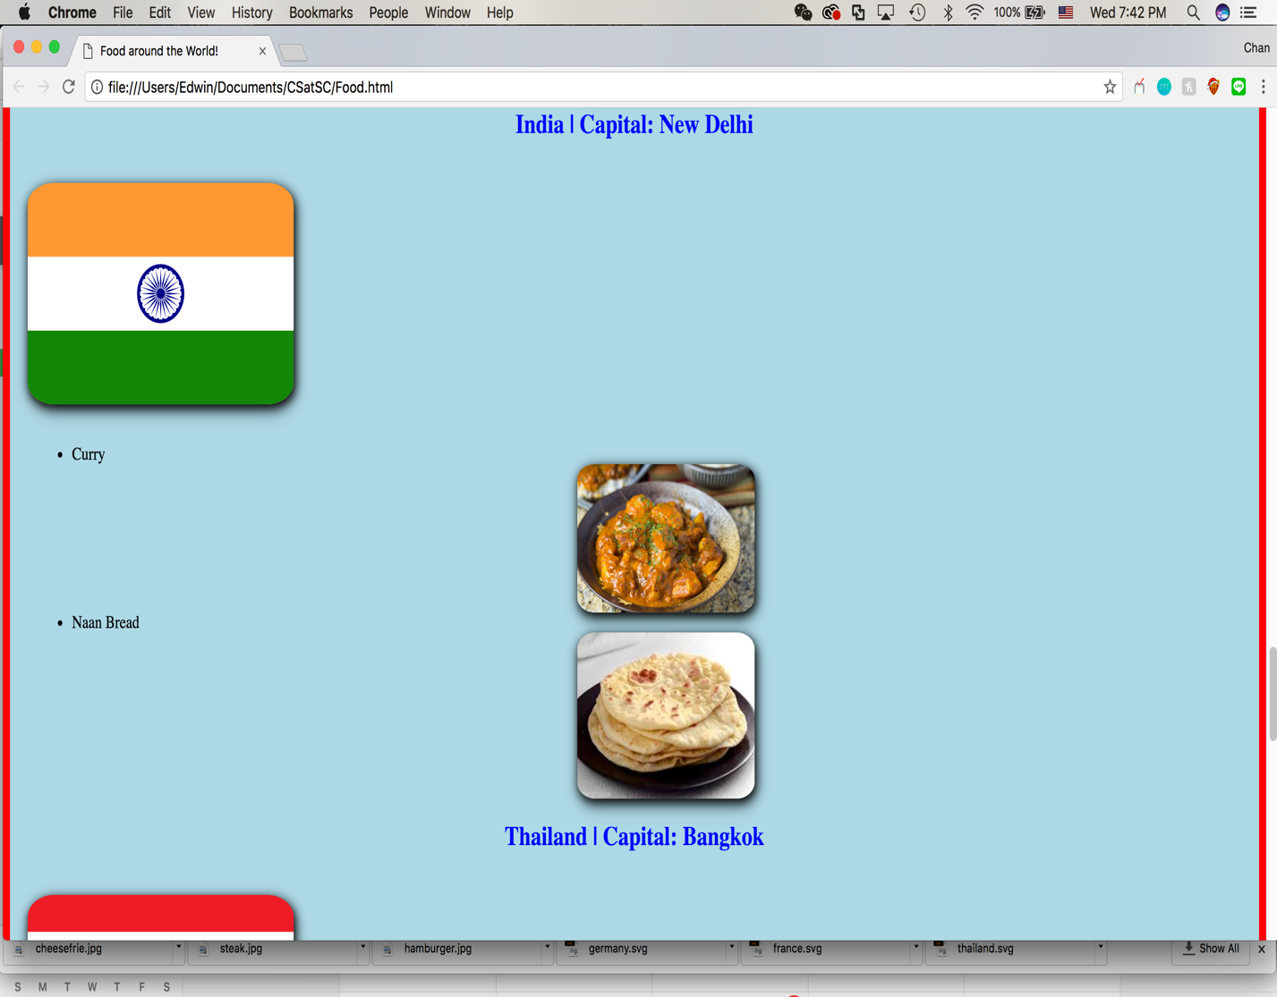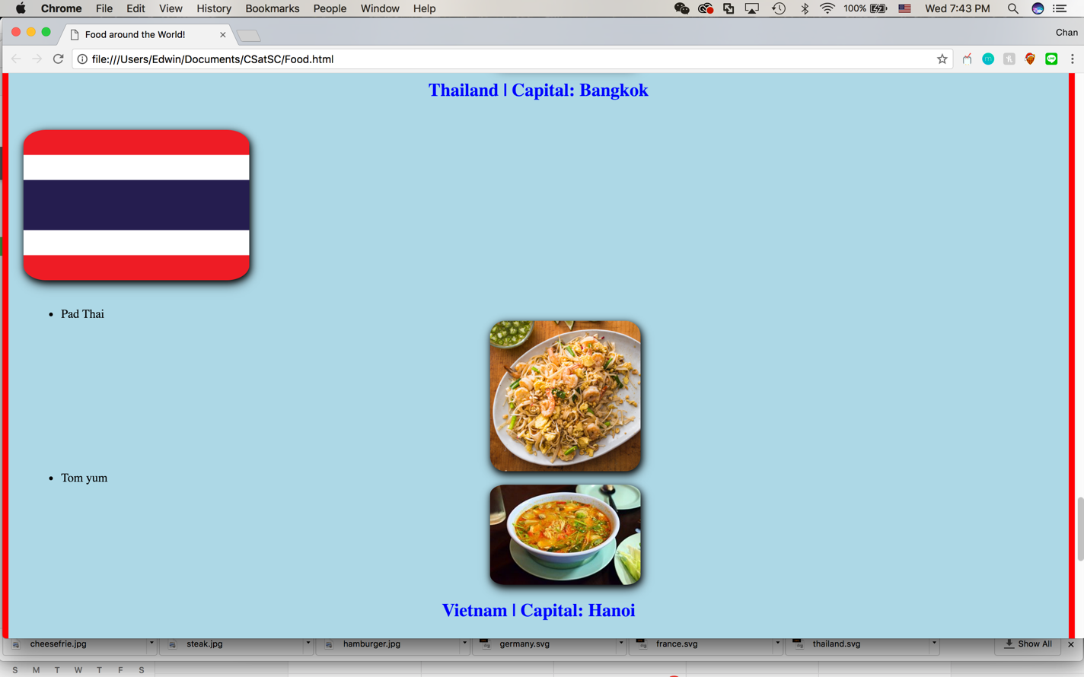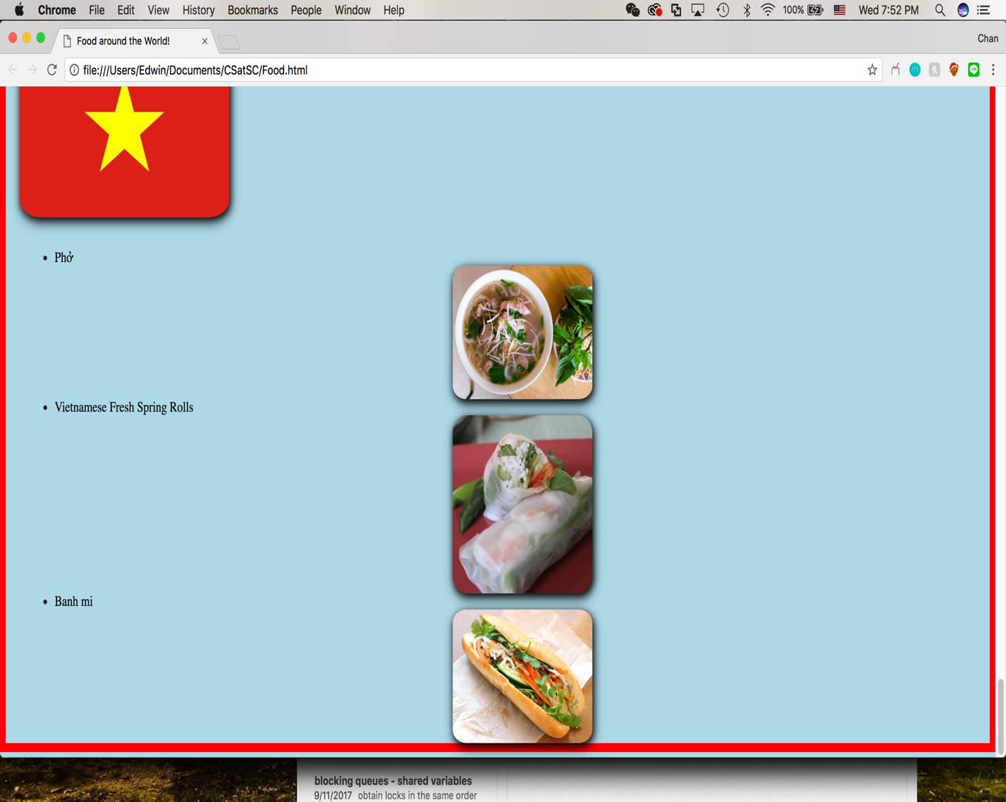

**Solutions ( food.css)**

body {

background-color: lightblue;

outline-style: solid;

outline-color: red;

outline-width: 10px;

}

h1 {

font-size: 40px;

text-align: center;

color:red;

letter-spacing: 2px;

word-spacing: 5px;

}

p {

font-family: verdana;

font-size: 15px;

}

img{

border-radius: 10%;

box-shadow: 0 3px 8px 0 rgba(0, 0, 0, 0.2), 0 5px 20px 0 rgba(0, 0, 0, 0.19);

filter: drop-shadow(2px 3px 5px black);

margin-left: 20px;

margin-top: 20px;

margin-bottom: 20px;

margin-right: 20px;

}

ul{

margin-left: 30px;

}

img:hover {

-webkit-transform: scaleX(-1);

transform: scaleX(-1);

}

.country{

color: blue;

text-align: center;

}

.food{

display: block;

margin: auto;

}

**Food.html**

<html>

<head>

<title>Food around the World!</title>

<link rel = "stylesheet" type = "text/css" href = "food.css"/>

</head>

<body>

<h1>Food Around the World!</h1>

<p> There are so many kinds of cuisines around the world! On the webpage I will show <em>some</em> of the popular ones. From:<br /> </p>

<!-- USA !-->

<h2 class="country"> United States of America | Capital: Washington DC</h2>

<img src="usa.png" width="300" />

<ul type="disc">

<li> Hamburgers </li>

<img class="food" src="hamburger.jpg" width="200" />

<li> Steaks </li>

<img class="food" src="steak.jpg" width="200" />

<li> Cheese fries </li>

<img class="food" src="cheesefries.jpg" width="200" />

</ul>

<!-- Hong Kong!-->

<h2 class="country"> Hong Kong </h2>

<img src="hongkong.png" width="300" />

<ul type="disc">

<li> Dimsum </li>

<img class="food" src="dimsum.jpeg" width="200" />

<li> Sweet and Sour Pork </li>

<img class="food" src="sweet.jpg" width="200" />

<li> Egg Tarts </li>

<img class="food" src="eggtart.jpeg" width="200" />

</ul>

<!-- Germany !-->

<h2 class="country"> Germany | Capital: Berlin</h2>

<img src="germany.svg" width="300" />

<ul type="disc">

<li> Schweinshaxe </li>

<img class="food" src="Schweinshaxe.jpg" width="200" />

<li> Nürnberger Rostbratwurst </li>

<img class="food" src="NürnbergerRostbratwurst.jpeg" width="200" />

<li> Brezel </li>

<img class="food" src="Brezel.jpg" width="150" />

</ul>

<!-- France !-->

<h2 class="country"> France | Capital: Paris</h2>

<img src="france.svg" width="300" />

<ul type="disc">

<li> Macaron </li>

<img class="food" src="macaron.jpg" width="200" />

<li> Crème Brûlée </li>

<img class="food" src="creme.jpeg" width="200" />

</ul>

<!-- Japan !-->

<h2 class="country"> Japan | Capital: Tokyo</h2>

<img src="japan.svg" width="300" />

<ul type="disc">

<li> Sushi </li>

<img class="food" src="sushi.jpeg" width="200" />

<li> Ramen </li>

<img class="food" src="ramen.jpg" width="200" />

<li> Tempura </li>

<img class="food" src="tempura.jpg" width="200" />

</ul>

<!-- India !-->

<h2 class="country"> India | Capital: New Delhi</h2>

<img src="india.svg" width="300" />

<ul type="disc">

<li> Curry </li>

<img class="food" src="curry.jpg" width="200" />

<li> Naan Bread </li>

<img class="food" src="naan.jpeg" width="200" />

</ul>

<!-- Thailand !-->

<h2 class="country"> Thailand | Capital: Bangkok</h2>

<img src="thailand.svg" width="300" />

<ul type="disc">

<li> Pad Thai </li>

<img class="food" src="pad.jpg" width="200" />

<li> Tom yum </li>

<img class="food" src="tom.jpg" width="200" />

</ul>

<!-- Vietnam !-->

<h2 class="country"> Vietnam | Capital: Hanoi</h2>

<img src="vietnam.png" width="300" />

<ul type="disc">

<li> Phở </li>

<img class="food" src="pho.jpeg" width="200" />

<li> Vietnamese Fresh Spring Rolls </li>

<img class="food" src="spring.jpg" width="200" />

<li> Banh mi </li>

<img class="food" src="banh.jpg" width="200" />

</ul>

</body>

</html>